**On Etsy and eBay, modders are selling Silent AirTags.**

The anti-stalking feature on Apple's iPhone was bypassed.

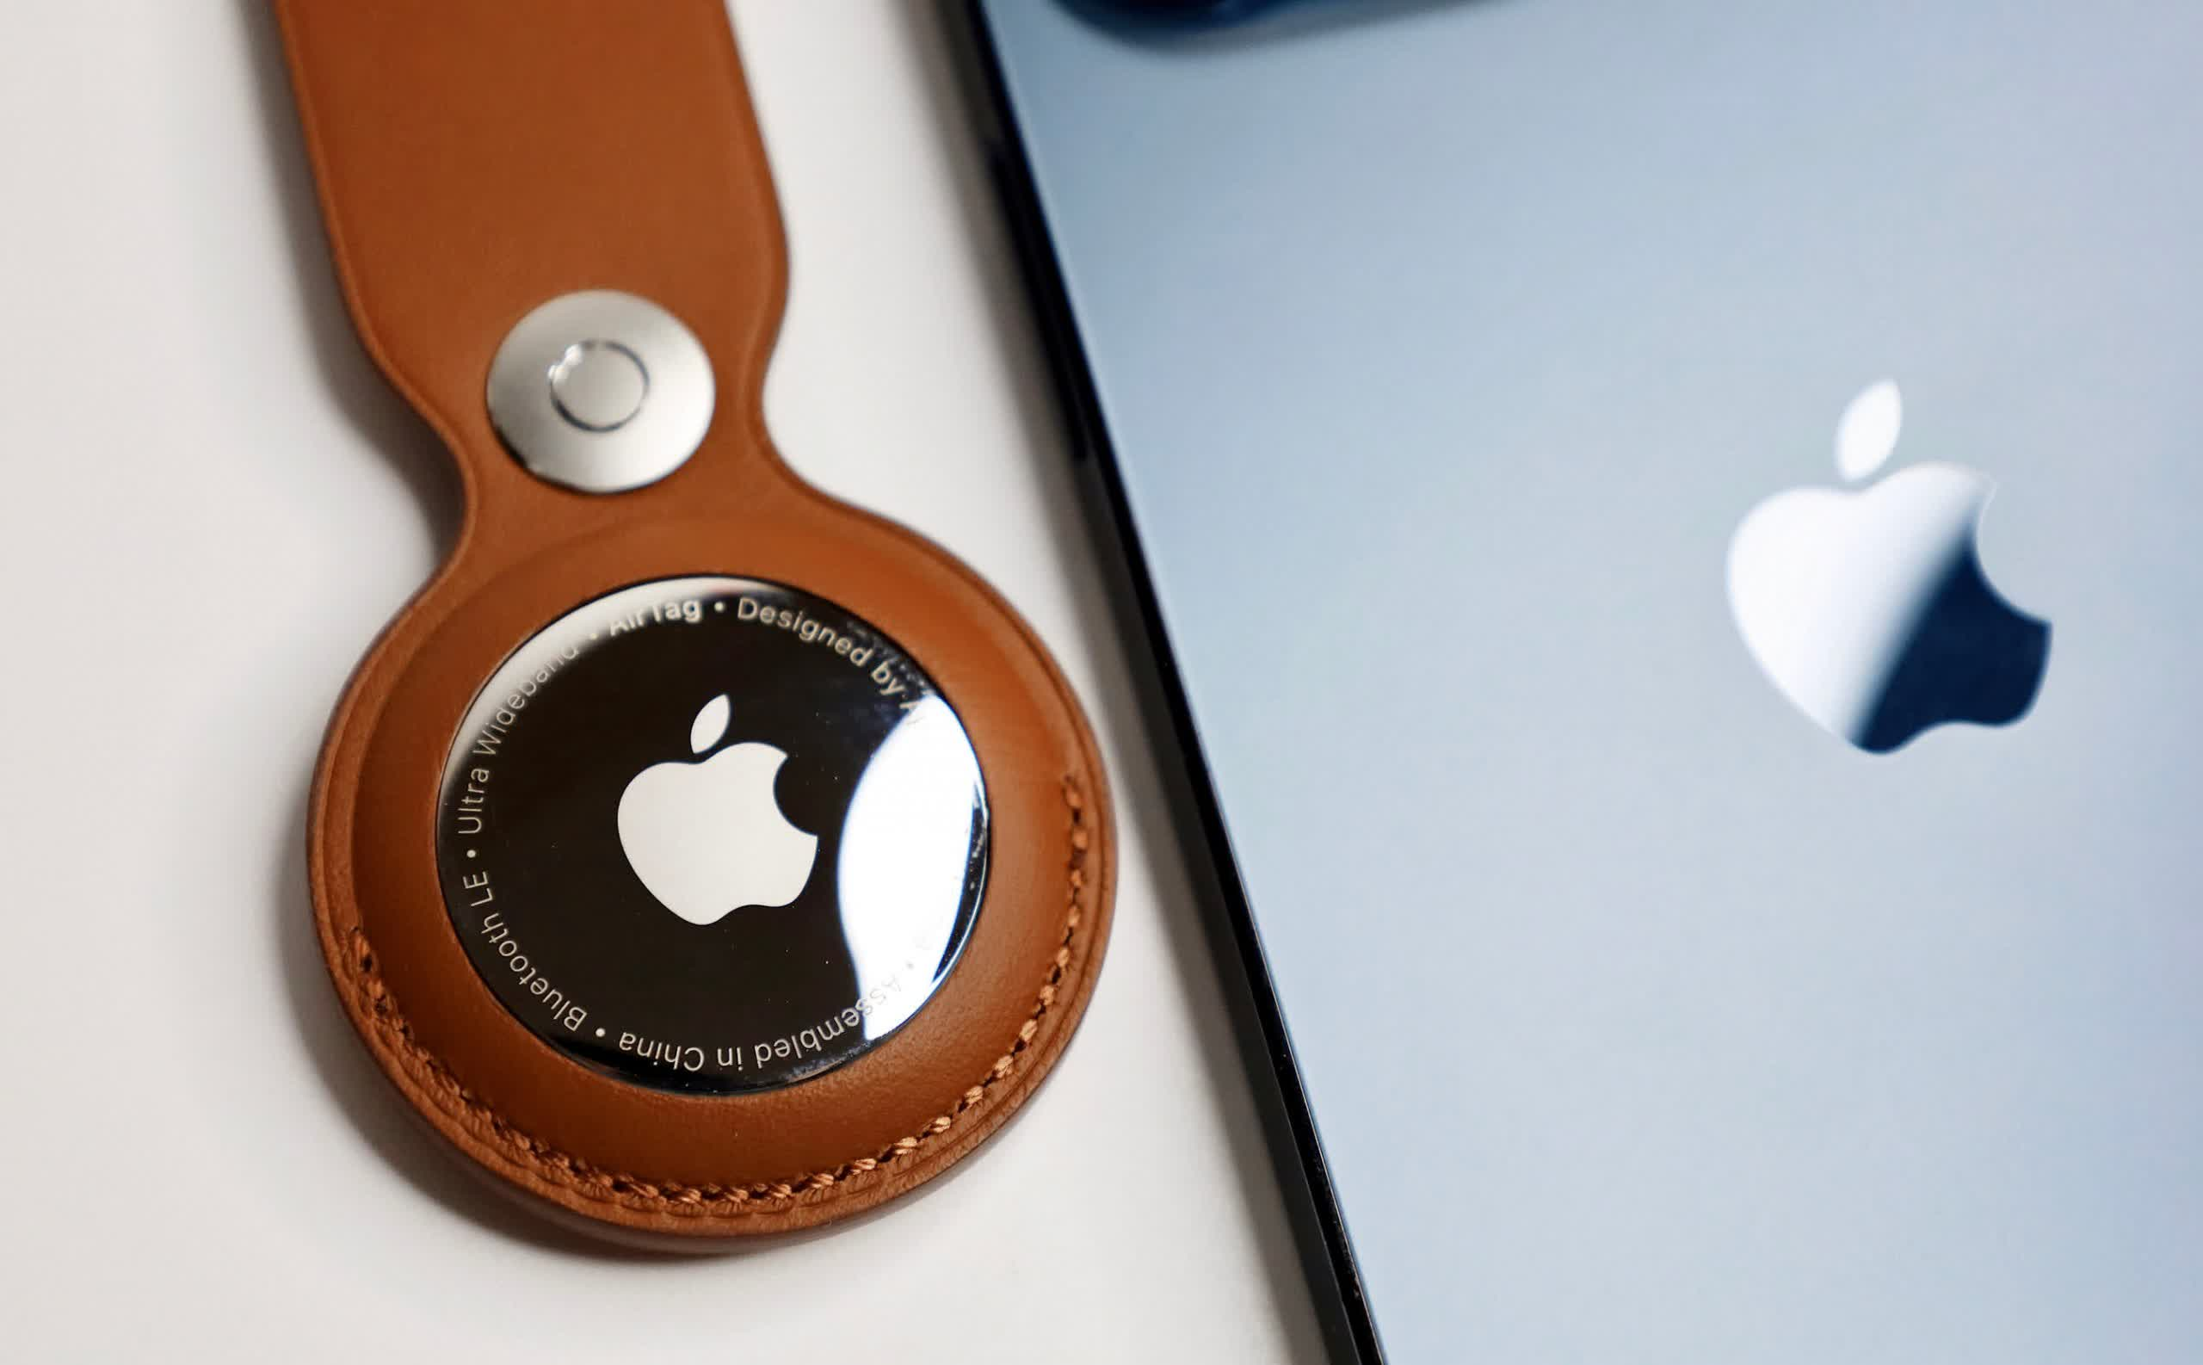

People have warned that stalkers may use Apple's AirTag tracking fobs to discreetly find or shadow targets since they were released. People continue to find methods around Apple's attempts to make them safer, even as the company strives to make them safer. One of the physical precautions, the speaker that warns unwitting victims of the device's presence, has been disabled.

There have been stories of AirTags being used to stalk someone for months. They've also been used by thieves to track cars and then steal them. AirTags are designed to send out a warning if they are removed from their owners for more than a few hours, but some people are figuring out how to disable that feature.

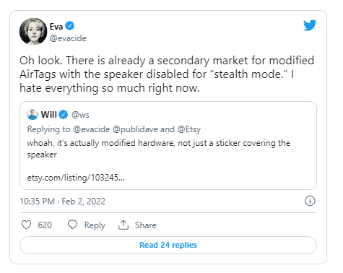

PCMag identified numerous AirTags with disabled speakers on eBay and other internet marketplaces this week. Eva Galperin, Director of Cybersecurity at the Electronic Frontier Foundation, expressed concern after seeing one on Etsy. The listings on Etsy and eBay have subsequently been removed.



The seller on Etsy informed PCMag that he intended to sell the AirTags after modifying them by cutting a small hole to disable the speaker. While user JTEE3D acknowledged that silent AirTags may be used for "malicious conduct," he expected them to be used to track personal items without having to deal with the warning sound. The seller on eBay said that if a burglar steals an item with an AirTag connected, the warning beep may reveal the AirTag to the thief.

Regardless of whether or not the listings are deleted, we may expect thieves and other nefarious characters to deactivate the speakers themselves now that the flaw has been discovered.